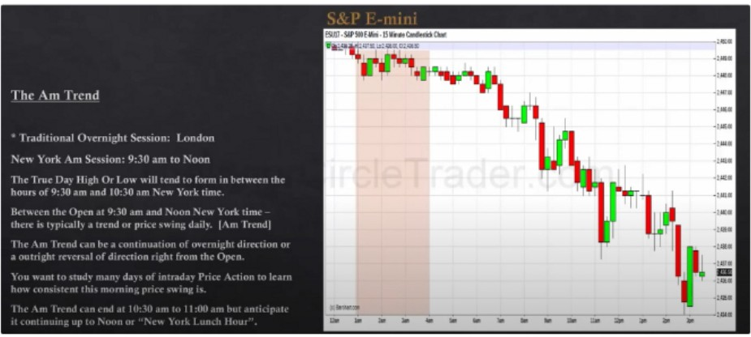**AM Trend**

**ESUlJ.S&P.E.Mii.15.....C. Ollrl**

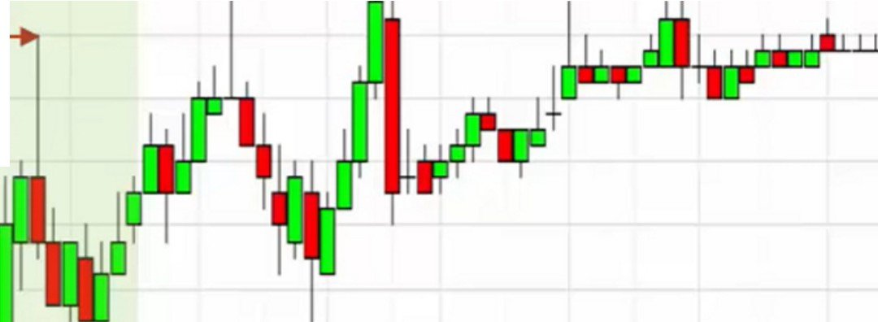

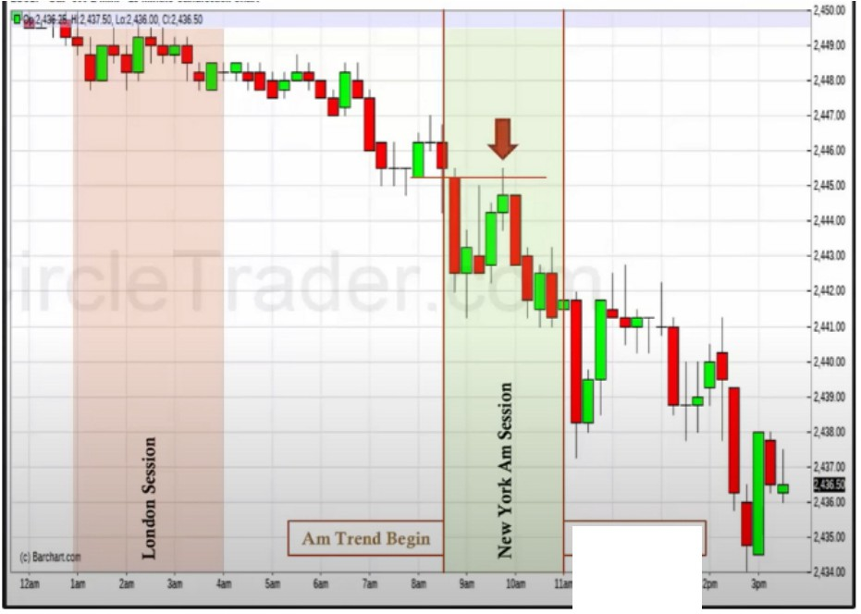

**AmTttnd End**

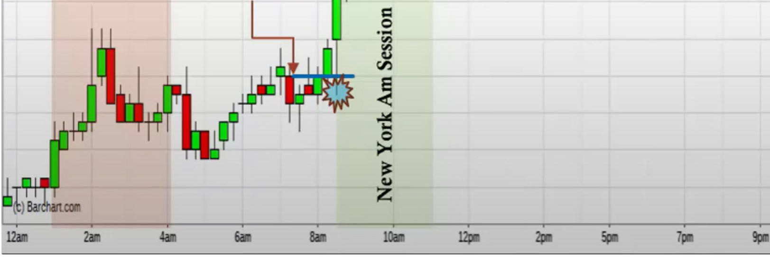

ESU17 • S&P 500 E-Mini .15 Minute Candle51ick Chart

2,452.00

=.**0**..

-2,45LOO

10:30am NY

"'

**m**

- 2,449.00

=**j**

=

**tr.)**

.g

-2,448.00

-2,447.00

-2,446.00

-2,445.00

-2,444.00

-2,443.00

-2,442.00

Bullish Orderblock

-2,44LOO

-2,440.00

-2,439.00

-2,438.00

-2,437.00

-2,43600

**l.l.pa**

2,43500



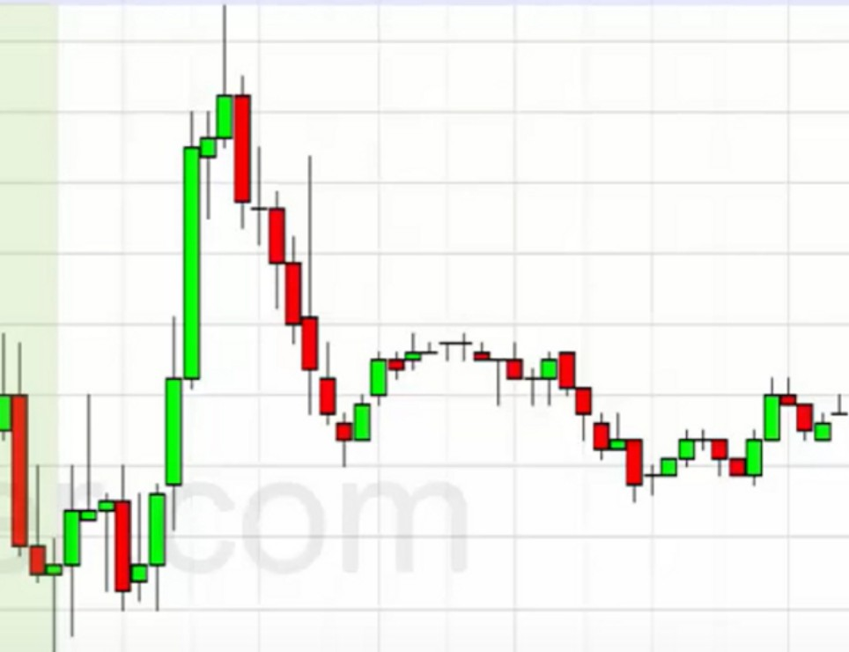It fills the gap only with wicks, we like to see bodies, the bodies has to cross for it to be efficient price

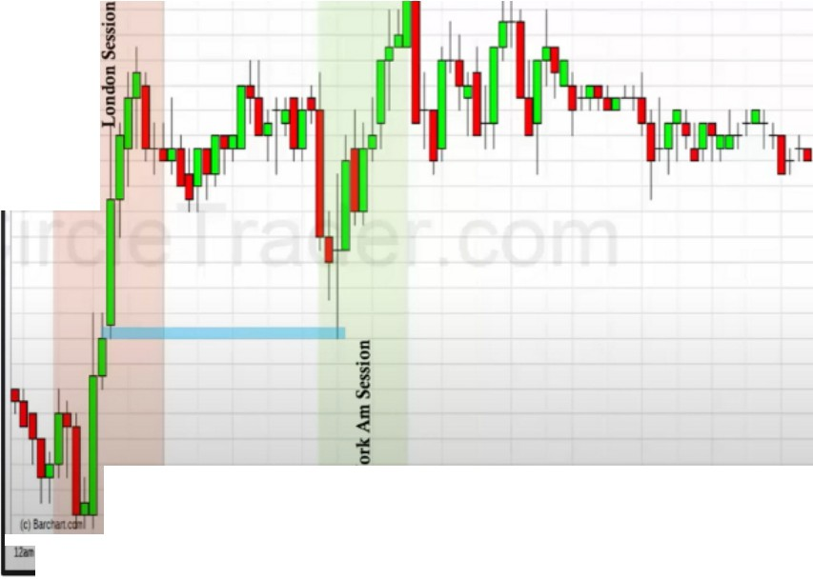

--1-.......*=*...*. - ---=.-----------------,.*., *•*

**ESlllJ-SlP.E-illli-lSMMCM'lllnld;Olart**

.,...

.,...

.........

.,,...,..

....,.

**·BIi**

.,.,..

..........

......

.....

..,,,,....

.,..,_.

.,....

.,....

.. .. .. .. .. ..,......

..........

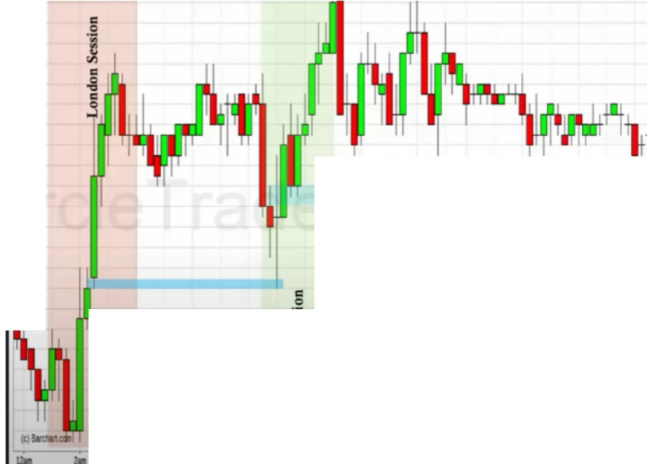

**l'""•-=•'--="=•lll!O"'OUOO""'"**

**ESMl.7,5'P5NE,._,1S._. o.i**

**,...**

**·J,al:O**

.·2,..•.50

.,..,

..

**·2.17.0)**

**•2,a!iO**

...

**-2,a(**

**Bullish Ordublock**

..,...,...

..,,,.,,...

.

**I)**

**·BIi**

.-,.­,._.

**·l.lll!O**

.,...

.....

* **2,JH.O)**

.

....

.

..

**·2.**■**:0**

**·at•**

"'

**--1.•:ia**

...

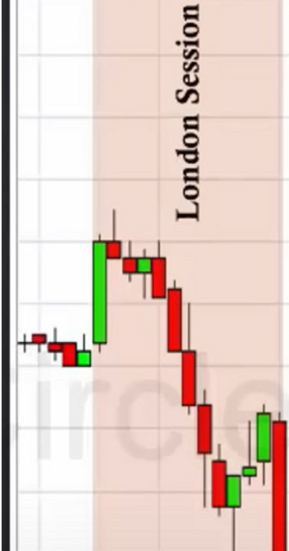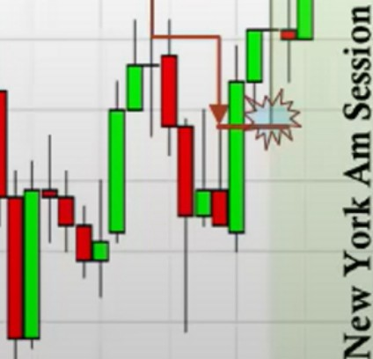

**ESM17** - **S&P500E-Min-i15Minute Candlestick Chart**

**--------36150-. 2,3 6.00**

**2,374.00**

**2,372.00**

**2,370.00**

**2,368.00**

2,366.00

**Be**

2,362.00

2,360.00

2,358.00

**Bullish Orderblock**

2,356.00

2,354.00

2,352.00

2,35000

2, 00

I (c)Barcllan.COII'

2,34600

'--· -- --- -- --- --- --- --- -- --- --- -- ---'2,34400

**12n 2al lOII**



That expansion higher can be expected by them taking the sell stops in London

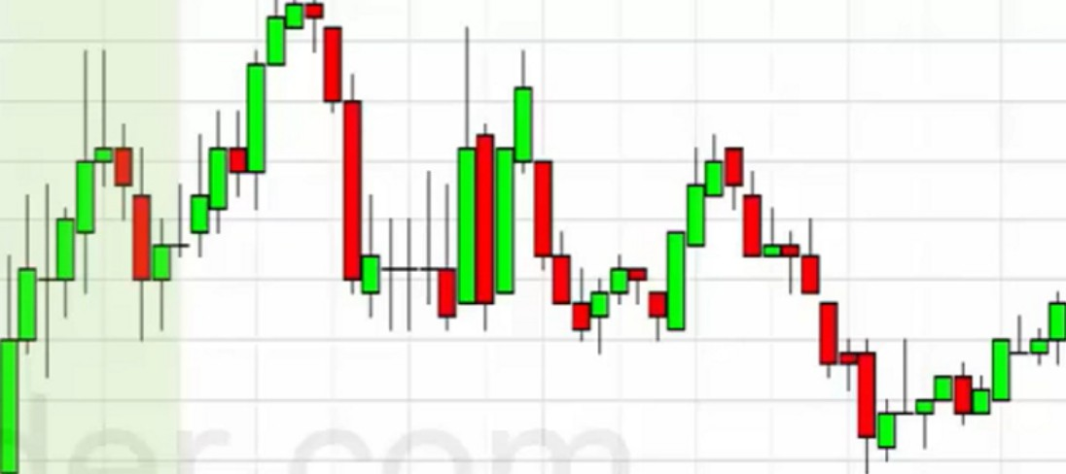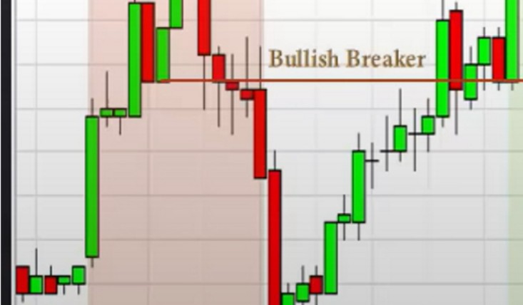

■,

YMM17 • Dow lndu30E-Mi-ni15Minute Candlestick Chart

,929,Lo:20923Ct20928

,20,965

20,9(,0

20,955

20,950

20,945

-

20,940

20,935

20,925

20,920

20,915

20,910

20.

20,900

.0.c.:.:

**(,I)**

""u''

Sell Stops

(c)Baichan.com

**l2all**

>0 -

z**u**

-20,895

20,890

20.885

20,880

20.875

20.870

20865

- '20860

**2n**

**4aa**

**6aa**

**8aa**

**121D**

*ii-*

**5j)a**

**pa**

.0.c.:.:

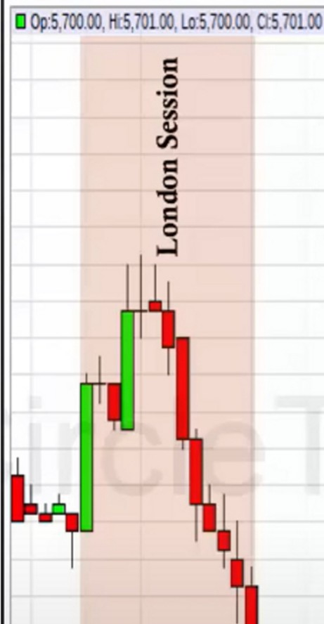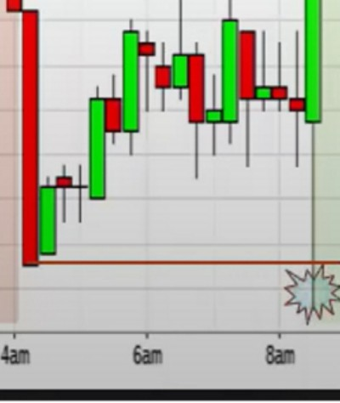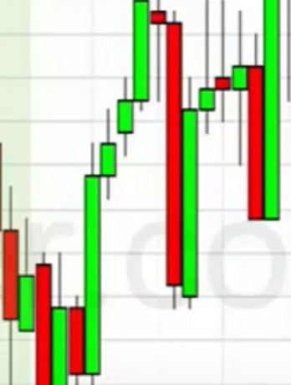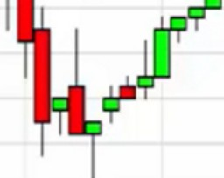

NQM17. Nasdaq 100 E-Mini .15 Minute Candlestick Chart

5,707.00

*,*

5,7 .00

5.,00

'

-

5,™.00

5,703.00

5,702.00

5,700.00

5,699.00

"'

**(,I)**

**.**.**:,**.**c**.

>0 -

I (c) Barcl.-tCCII' •

z

**u**

12n

2n

***w.***

5,698.00

5,697.00

5,696.00

5,695.00

5,694.00

5,693.00

5,692.00

5,69LOO

5,690.00

5,689.00

5,688.00

5,687.00

5,686.00

5,685.00

5,684.00

5,68300

5,682.00

Index SMT

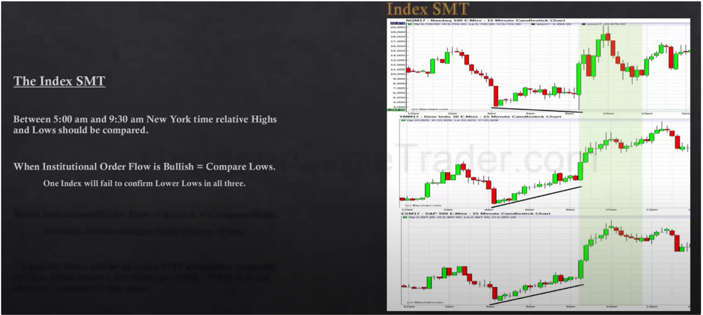

When 1 fails to make a lower low thats our bullish confirmation for the AM trend It isnt always going to be like this, the low at 7am for example could also diverge

Between 5am and 930am is where were constantly scouting, when HTF institutional orderflow is bullish and we drop to a 4h or 1h basis and look for PD arrays and we expect bullish prices, then were going to be looking for price to fail to make a lower low when its retracing we see that footprint of smart money in the index SMT. Significant trading opportunities will always have this hallmark to it

Dont think the lows are exactly at 5am and 9am its more like a killzone

Why are we looking at 5am? Because London traders are going to be taking their lunch then Large pools of money will flow into the market at 930

You can see the massive build up on the lows so you know with a great deal of confidence that on NAS the SSL run is a stop run

When the SMT happens we are looking for an expansion move, what ICT does is he looks to be a buyer on a stop above an old high downclosed candle

When this happens and only 1 makes a lower low, your eyes should immediately go to the 1 thats making a lower low and expect it to be a turtle soup, so you can do either 1 of the 2, buying on strength with a stop order or buy on weakness under the old low with a market order, either one is fine

_.

,:; ,-

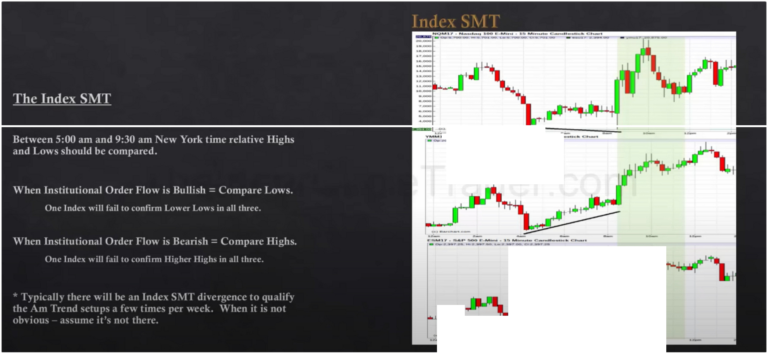

, .-. ,-_-

... =-­

**..J'**

***t'"'***

- - -

**,1 ,.-i-·**

Dont strain your eye looking for them, if it isnt clear then assume its not there

It removes the fear of the question: "How do i know if its a turtle soup and that price wont just keep on running?" When you see this, high high probability its a turtle soup

The speed that makes the lower low will be very high, the speed will be there but it doesnt always relate to magnitude

If a day is bullish and the market rallies all AM session, then the PM session will seek sellside under AM session lows and reprice to any BISI (Buyside imbalance sellside inefficiency) once it is there expect a return to premium inside the range.

Arjo I Twitter, lnstagram I Linktree

Linktree. Make your link do more. https://t.co/HhmmTN1fUI

JavaScript is not available.

***"!I*** https://twitter.com/arjoio